Test Report (Redy)_추가실험
- 발 걸려 넘어지는 동작 세부 실험 -
2025.6.19
SW개발실

추가동작실험

목적
- 걸어가다 발 걸려서 전방전도하는 동작 세부 분석
- 실험프로토콜
- EF01. 걸어가다 발 걸려서 무릎 닿고 전방전도
- EF02. 걸어가다 발 걸리지 않고 무릎 닿고 전방전도
- EF03. 걸어가다 발 걸리고 무릎 닿지 않고 전방전도
- EF04. 걸어가다 발 걸리지 않고 무릎 닿지 않고 전방전도

실험결과 요약
- 발 걸리는 충격의 영향은 그렇게 크지 않음
- 문제는 무릎부터 접촉이 되는 경우 발생되며,
해당 경우에는 무릎이 닿은 이후에 검출이 되게 됨
Code | Motion | Detection | Lead-time (ms)
EF01 | 걸어가다 발 걸려서 무릎 닿고 전방전도 | ✔️ | 320 (몸) / -80 (무릎)
EF02 | 걸어가다 발 걸리지 않고 무릎 닿고 전방전도 | ✔️ | 80 (몸) / -180 (무릎)
EF03 | 걸어가다 발 걸리고 무릎 닿지 않고 전방전도 | ✔️ | 140 (몸)
EF04 | 걸어가다 발 걸리지 않고 무릎 닿지 않고 전방전도 | ✔️ | 160 (몸)

세부실험결과
- EF01. 걸어가다 발 걸려서 무릎 닿고
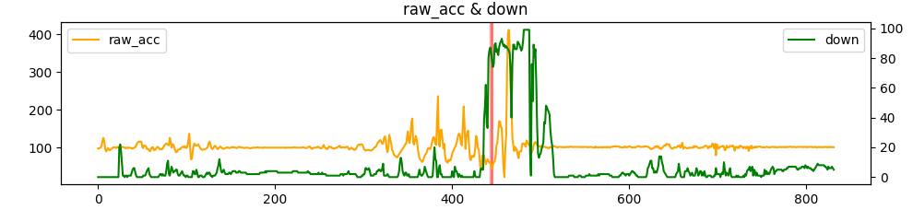
EF01_DSV.csv
down raw_acc raw_gyro vv pitch roll jerkA detected_modes
402 0 96 66 7.14 5 6 6.0 []
403 7 100 62 7.84 5 6 4.0 []
404 4 105 65 7.45 5 6 5.0 []
405 4 112 70 7.94 6 6 7.0 []
406 2 124 74 7.34 6 6 12.0 []
407 0 135 74 6.97 6 6 11.0 []
408 2 137 69 6.62 6 5 2.0 []
409 1 131 54 6.29 5 5 -6.0 []
410 0 110 31 5.97 5 5 -21.0 []
411 1 106 46 5.68 5 4 -4.0 []
412 0 157 63 5.39 5 4 51.0 []
413 0 209 78 5.12 6 3 52.0 []
414 0 157 87 4.87 6 2 -52.0 []
415 0 97 52 4.62 5 1 -60.0 []
416 0 128 43 4.39 5 0 31.0 []
417 0 139 50 4.17 5 0 11.0 []
418 0 145 20 3.96 5 0 6.0 []
419 0 106 30 3.77 5 -1 -39.0 []
420 0 74 28 3.58 4 0 -32.0 [1]
421 0 67 25 3.40 3 0 -7.0 [1]
422 0 78 43 3.23 4 0 11.0 []
423 0 75 58 4.16 4 0 -3.0 [1]
424 0 79 60 4.12 4 0 4.0 []
425 4 77 68 5.10 5 0 -2.0 [1]
426 1 98 58 5.07 6 0 21.0 []
427 0 131 63 5.92 6 0 33.0 []
428 0 124 49 5.43 7 0 -7.0 []
429 0 99 44 5.76 7 0 -25.0 []
430 0 96 54 5.47 6 0 -3.0 []
431 0 71 55 5.20 5 0 -25.0 [1]
432 5 45 42 4.94 5 1 -26.0 [1]
433 6 54 25 6.23 4 1 9.0 []
434 5 78 17 6.37 4 2 24.0 []
435 5 78 27 7.65 3 2 0.0 []
436 39 79 37 7.56 3 2 1.0 []
437 47 66 38 8.71 2 2 -13.0 [1]
438 62 56 32 8.67 1 2 -10.0 [1]
439 36 63 37 9.99 1 2 7.0 []
440 33 69 53 10.08 0 2 6.0 []
441 80 64 72 11.41 -1 2 -5.0 [1]
442 85 60 71 11.46 -2 2 -4.0 [1, 3]
443 87 61 76 12.82 -3 2 1.0 []
444 83 57 92 12.94 -5 2 -4.0 [1, 2]
445 78 45 99 14.39 -6 2 -12.0 [1, 2]
446 74 55 110 14.68 -8 2 10.0 []
447 76 61 124 16.24 -10 2 6.0 []
448 89 63 136 16.44 -13 2 2.0 []
449 90 75 134 17.85 -15 2 12.0 []
450 84 107 149 17.81 -18 2 32.0 []
451 86 111 168 18.74 -21 2 4.0 []
452 82 142 173 18.14 -24 3 31.0 []
453 87 170 205 18.41 -28 3 28.0 []
454 90 169 218 17.49 -32 4 -1.0 []
455 91 155 225 16.62 -36 5 -14.0 []
456 93 152 228 15.79 -40 5 -3.0 []
457 90 100 234 15.00 -44 5 -52.0 []
458 88 47 224 14.25 -43 6 -53.0 []
459 89 22 216 13.53 -48 6 -25.0 []
460 87 94 193 12.86 -52 6 72.0 []
461 88 133 205 16.25 -56 6 39.0 []
462 87 300 238 14.42 -60 6 167.0 []
463 86 402 179 14.93 -65 5 102.0 []
464 85 412 59 14.19 -68 5 10.0 []
465 83 363 33 13.48 -70 5 -49.0 []
Predict as Fall motion: True
Lead time: 320 ms
impact: 461
detect: 445
judge time: 660 ms
fall_onset: 412
← 발 걸림으로 인한 충격
← 무릎 닿음으로 인한 충격
- EF01. 걸어가다 발 걸리지 않고 무릎 닿고 전방전도
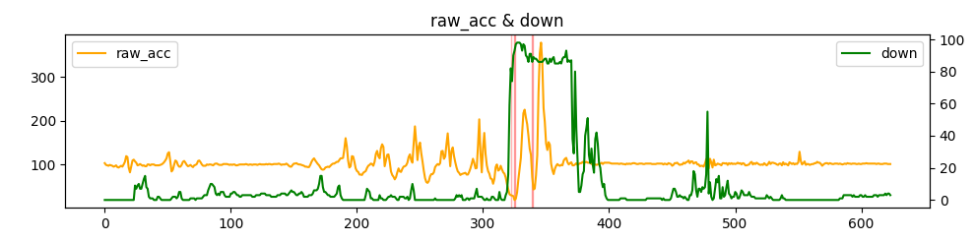
EF02_DSV.csv
down raw_acc raw_gyro vv pitch roll jerkA detected_modes
282 2 76 11 3.16 11 -7 -5.0 [1]
283 3 78 14 3.86 11 -7 2.0 []
284 0 79 22 3.84 11 -6 1.0 []
285 0 80 28 4.60 10 -6 1.0 []
286 0 81 37 4.59 10 -6 1.0 []
287 1 77 41 5.35 10 -6 -4.0 [1]
288 1 77 40 5.36 9 -6 0.0 []
289 0 83 38 6.15 9 -6 6.0 []
290 1 91 35 6.12 9 -7 8.0 []
291 1 101 32 6.77 9 -6 10.0 []
292 1 113 26 6.51 9 -6 12.0 []
293 1 104 21 6.86 9 -6 -9.0 []
294 4 91 21 6.52 10 -6 -13.0 []
295 7 92 39 6.19 10 -5 1.0 []
296 2 143 70 5.88 10 -4 51.0 []
297 2 203 97 5.88 10 -3 60.0 []
298 2 126 90 5.59 10 -2 -77.0 []
299 2 82 32 5.31 10 -1 -44.0 [1]
300 1 138 18 5.04 10 -1 56.0 []
301 0 172 22 4.79 9 0 34.0 []
302 0 124 52 4.55 9 0 -48.0 []
303 1 98 50 4.32 8 0 -26.0 []
304 0 85 57 4.11 8 -1 -13.0 [1]
305 0 79 53 3.90 6 -1 -6.0 [1]
306 0 68 46 3.71 6 -2 -11.0 [1]
307 2 67 25 4.45 5 -2 -1.0 [1]
308 2 56 17 4.60 5 -2 -11.0 [1]
309 1 67 21 5.61 5 -2 11.0 []
310 0 94 20 5.87 5 -2 27.0 []
311 0 100 22 6.65 5 -2 6.0 []
312 0 86 28 6.53 4 -2 -14.0 [1]
313 5 88 26 7.14 4 -2 2.0 []
314 1 97 24 6.98 4 -2 9.0 []
315 0 89 37 7.52 4 -1 -8.0 [1]
316 0 82 42 7.33 3 -2 -7.0 [1]
317 0 79 45 7.95 2 -2 -3.0 [1]
318 3 70 49 7.90 2 -2 -9.0 [1]
319 5 55 50 8.73 1 -2 -15.0 [1]
320 16 43 57 9.00 0 -3 -12.0 [1]
321 59 32 60 10.23 -1 -3 -11.0 [1]
322 82 30 68 10.93 -2 -3 -2.0 [1, 2]
323 74 29 73 12.51 -3 -3 -1.0 [1]
324 90 28 74 13.44 -4 -4 -1.0 [1]
325 93 19 82 15.17 -6 -4 -9.0 [1, 2]
326 97 22 84 16.25 -7 -4 3.0 []
327 98 36 77 18.11 -8 -3 14.0 []
328 98 65 69 19.11 -10 -3 29.0 []
329 98 89 73 20.53 -11 -3 24.0 []
330 97 115 93 20.79 -12 -2 26.0 []
331 93 171 120 21.32 -14 -2 56.0 []
332 97 217 149 20.39 -16 -2 46.0 []
333 96 225 190 19.37 -19 -2 8.0 []
334 90 207 195 18.40 -22 -2 -18.0 []
335 89 192 206 17.48 -26 -2 -15.0 []
336 86 166 228 16.61 -30 -3 -26.0 []
337 91 136 237 15.78 -34 -3 -30.0 []
338 91 122 248 14.99 -38 -4 -14.0 []
339 86 72 231 14.24 -42 -5 -50.0 [1, 3]
340 89 43 230 13.53 -47 -6 -29.0 []
341 88 45 202 12.85 -51 -6 2.0 []
342 88 75 166 15.63 -55 -7 30.0 []
343 87 121 152 15.51 -59 -7 46.0 []
344 86 264 180 17.24 -63 -7 143.0 []
345 86 353 167 14.77 -66 -6 89.0 []
346 86 378 118 14.03 -69 -5 25.0 []
347 86 331 119 13.33 -71 -4 -47.0 []
348 87 229 102 12.66 -73 -2 -102.0 []
349 88 197 113 12.03 -74 0 -32.0 []
350 88 148 107 11.42 -75 1 -49.0 []
351 85 133 98 10.85 -76 3 -15.0 []
352 85 151 47 10.31 -77 5 18.0 []
353 88 145 45 9.80 -77 6 -6.0 []
354 86 102 23 9.31 -77 7 -43.0 []
355 88 87 28 8.84 -78 8 -15.0 []
356 89 78 34 8.40 -80 10 -9.0 []
357 85 90 19 7.98 -80 11 12.0 []
358 85 97 36 7.58 -81 11 7.0 []
359 85 101 47 8.27 -83 12 4.0 []
Predict as Fall motion: True
Lead time: 80 ms
impact: 343
detect: 339
judge time: 860 ms
fall_onset: 296
← 무릎 닿음으로 인한 충격
Jerk가 양수가 되고, raw_acc가 값이
커져서 낙상으로 검출 안 됨

- 걸어가다 발 걸리고 무릎 닿지 않고 전방전도
EF03_DSV.csv
down raw_acc raw_gyro vv pitch roll jerkA detected_modes
374 3 116 55 9.09 7 4 8.0 []
375 2 123 48 9.41 7 4 7.0 []
376 0 141 54 8.94 7 4 18.0 []
377 1 150 53 8.49 7 4 9.0 []
378 1 138 50 8.07 7 3 -12.0 []
379 1 109 46 7.66 6 3 -29.0 []
380 0 93 20 7.28 6 3 -16.0 []
381 0 146 39 6.92 5 2 53.0 []
382 0 159 74 6.57 5 2 13.0 []
383 0 151 84 6.24 5 1 -8.0 []
384 0 109 51 5.93 4 0 -42.0 []
385 5 109 68 5.63 3 0 0.0 []
386 0 159 65 5.35 2 0 50.0 []
387 0 169 91 5.08 1 0 10.0 []
388 0 138 102 4.83 0 -1 -31.0 []
389 0 111 111 4.59 -2 -1 -27.0 []
390 1 102 128 4.36 -4 0 -9.0 []
391 6 85 138 4.14 -7 0 -17.0 [1]
392 31 73 135 3.93 -10 0 -12.0 [1]
393 12 64 134 3.74 -12 0 -9.0 [1]
394 22 31 116 4.65 -15 1 -33.0 [1]
395 11 59 107 5.02 -17 1 28.0 []
396 5 92 86 6.23 -20 2 33.0 []
397 4 84 105 6.39 -22 2 -8.0 [1]
398 8 85 108 7.27 -24 2 1.0 []
399 13 85 120 7.24 -26 3 0.0 []
400 20 72 124 8.07 -28 4 -13.0 [1]
401 33 62 124 8.16 -30 4 -10.0 [1]
402 44 74 117 9.21 -33 5 12.0 []
403 31 105 110 9.33 -35 6 31.0 []
404 57 102 122 10.06 -37 6 -3.0 []
405 32 106 122 9.78 -38 6 4.0 []
406 3 130 100 10.21 -39 6 24.0 []
407 9 148 107 9.51 -41 6 18.0 []
408 0 131 106 9.03 -43 7 -17.0 []
409 0 84 92 8.58 -45 7 -47.0 [1]
410 0 75 76 8.15 -47 5 -9.0 [1]
411 1 48 73 7.75 -48 5 -27.0 [1]
412 54 46 56 9.44 -49 5 -2.0 [1]
413 81 47 47 10.03 -51 5 1.0 []
414 80 30 52 12.18 -52 5 -17.0 [1, 2]
415 85 23 82 12.89 -53 6 -7.0 [1, 2]
416 83 46 84 15.35 -54 6 23.0 []
417 84 48 98 16.08 -56 6 2.0 []
418 84 100 101 18.04 -57 6 52.0 []
419 84 98 96 18.05 -59 5 -2.0 []
420 84 31 97 19.40 -61 5 -67.0 [1, 2]
421 84 85 118 19.61 -62 4 54.0 []
422 84 76 103 21.83 -64 3 -9.0 []
423 84 86 62 22.00 -65 2 10.0 []
424 84 72 22 23.71 -67 2 -14.0 []
425 85 81 41 23.49 -67 2 9.0 []
426 85 26 88 25.18 -67 2 -55.0 []
427 86 404 140 25.03 -69 2 378.0 []
428 86 401 211 24.69 -70 4 -3.0 []
429 88 415 174 20.07 -71 6 14.0 []
430 82 503 225 19.07 -72 9 88.0 []
431 84 308 112 18.11 -73 12 -195.0 []
432 91 135 101 17.21 -73 15 -173.0 []
433 91 167 39 16.35 -74 17 32.0 []
434 90 81 49 15.53 -74 18 -86.0 []
435 86 105 17 14.75 -78 19 24.0 []
436 87 94 85 14.01 -81 19 -11.0 []
437 86 63 132 13.31 -82 18 -31.0 []
438 85 86 106 12.65 -82 17 23.0 []
439 85 70 79 14.09 -83 15 -16.0 []
440 93 96 52 13.52 -83 14 26.0 []
Predict as Fall motion: True
Lead time: 140 ms
impact: 427
detect: 420
judge time: 760 ms
fall_onset: 382
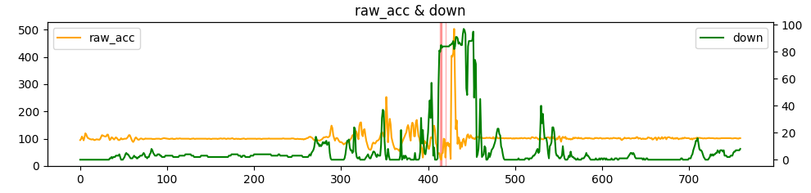
← 발 걸림으로 인한 충격
- EF04. 걸어가다 발 걸리지 않고 무릎 닿지 않고 전방전도
EF04_DSV.csv
down raw_acc raw_gyro vv pitch roll jerkA detected_modes
449 0 93 41 3.36 3 -4 -15.0 []
450 0 88 36 3.19 1 -4 -5.0 [1]
451 1 80 30 3.03 -1 -4 -8.0 [1]
452 0 81 30 2.88 -1 -4 1.0 []
453 0 81 30 3.49 -2 -4 0.0 []
454 0 83 33 3.47 -3 -3 2.0 []
455 0 84 41 4.12 -3 -3 1.0 []
456 0 87 44 4.09 -4 -3 3.0 []
457 0 89 46 4.70 -5 -3 2.0 []
458 2 92 45 4.60 -6 -2 3.0 []
459 2 98 46 5.13 -6 -2 6.0 []
460 3 101 45 4.91 -7 -2 3.0 []
461 2 96 50 5.31 -7 -1 -5.0 []
462 2 94 52 5.03 -8 -1 -2.0 []
463 1 99 52 5.44 -8 -1 5.0 []
464 0 96 58 5.16 -8 -1 -3.0 []
465 4 89 58 5.56 -8 -1 -7.0 [1]
466 16 80 53 5.35 -9 -1 -9.0 [1]
467 20 69 48 5.94 -10 -1 -11.0 [1]
468 46 88 48 5.98 -11 -1 19.0 []
469 2 163 56 6.55 -11 -1 75.0 []
470 32 119 111 5.97 -12 -1 -44.0 []
471 78 67 108 5.67 -14 -1 -52.0 [1]
472 84 76 85 5.39 -16 -1 9.0 []
473 90 106 80 5.12 -18 0 30.0 []
474 95 111 97 5.77 -19 0 5.0 []
475 45 93 103 5.23 -21 0 -18.0 []
476 51 96 101 4.97 -23 0 3.0 []
477 73 111 106 4.72 -24 0 15.0 []
478 53 112 111 4.95 -26 0 1.0 []
479 60 117 113 4.70 -28 -1 5.0 []
480 57 108 119 4.47 -29 -1 -9.0 []
481 19 106 125 4.24 -31 -2 -2.0 []
482 12 104 128 4.03 -33 -3 -2.0 []
483 28 86 123 3.83 -34 -4 -18.0 [1]
484 33 67 113 3.64 -36 -5 -19.0 [1]
485 52 47 109 3.46 -38 -5 -20.0 [1]
486 76 17 112 4.67 -40 -5 -30.0 [1]
487 88 23 95 5.30 -42 -4 6.0 []
488 89 53 88 7.46 -44 -4 30.0 []
489 81 48 72 8.56 -46 -4 -5.0 [1, 2]
490 85 31 66 10.38 -48 -4 -17.0 [1, 2]
491 83 19 69 11.35 -49 -4 -12.0 [1, 2]
492 84 18 84 13.29 -51 -4 -1.0 []
493 84 19 83 14.43 -52 -3 1.0 []
494 84 23 84 16.49 -53 -2 4.0 []
495 84 57 78 17.67 -55 -2 34.0 []
496 85 65 75 19.46 -56 0 8.0 []
497 84 69 90 20.07 -56 0 4.0 []
498 87 33 82 21.41 -56 1 -36.0 []
499 86 185 73 22.20 -56 2 152.0 []
500 95 436 150 23.56 -57 4 251.0 []
501 84 440 134 20.23 -58 5 4.0 []
502 84 412 181 19.22 -61 6 -28.0 []
503 83 513 106 18.26 -63 7 101.0 []
504 87 339 32 17.34 -64 8 -174.0 []
505 86 118 73 16.48 -65 8 -221.0 []
506 92 111 73 15.65 -66 8 -7.0 []
507 90 90 85 14.87 -67 7 -21.0 []
508 94 80 90 14.13 -71 6 -10.0 []
509 92 65 74 13.42 -72 5 -15.0 []
510 91 65 67 12.75 -72 4 0.0 []
511 90 70 63 14.33 -73 2 5.0 []
Predict as Fall motion: True
Lead time: 160 ms
impact: 499
detect: 491
judge time: 600 ms
fall_onset: 461
